# Unitarian Universalist Community Church Of Hendricks County (UUCCHC) Annual Meeting Letter

We are inviting you to join us for the Annual Meeting of the Unitarian Universalist Community Church of Hendricks County, on April 27, 2025 at 10:00 am.

We have a very full agenda (below) thus we will have a shortened service with some music, joys and concerns, and a discussion about the status and future of the church. We have had a challenging but also rewarding year. We have recovered from the loss of some key members, with little notice and few future services planned. Now we are having high quality services with discussion after. We continue providing live music for nearly all of our services. We also have a verbal agreement with Rev. Elizabeth Price (Rev. Elizabeth) to provide sermons twice a month for March, April and May. She will join us at coffee hour most Sundays. If everyone continues to like her and her sermons, and we see her effect on the church as beneficial, we will consider continuing and possibly expanding our relationship with her.

We have also restarted Religious Exploration with, as I write this, with 3 young children. We are advertising regularly in Hendricks County Connections, the Republican Newspaper and Facebook. And we are getting visitors in and growing again!

We are pleased to report that the church records continue to get in better shape since we brought on Amy Hayden as Administrative Assistant. We are also implementing electronic record keeping under the direction of Bill Sutton who has been helping with technical details. This is making records easily available and much harder to lose track of. We are also implementing a calendar reminder system for repetitive tasks, for the admin, the facilities management and other committee and officer positions as well as the board. Among other things, the system teaches new board members how to set up board communications and where to find the policies and procedures to properly run the board.

Building repair recommendations will be discussed on another page. Note that the Facilities committee chair will offer a meeting to get into the weeds on issues related to building repair roughly two weeks before the annual meeting. Although it will be announced in the newsletter, if you want to be sure you know about it, email President@uucchc.org indicating your interest.

Please see our meeting agenda on the following page. We are excited about what is happening at our church! We look forward to seeing you on the 27th!

Annie Johnson

Board President

Attachments:

Agenda Budget

Building repairs overview By-Laws changes

**UUCCHC Annual Meeting Agenda**

* Calling the meeting to order: 10:00 am
* Election of Board Members
  + Call for candidates from the floor
  + Introduce candidates and invite them to address the congregation
  + Call the vote
* Elect representatives for the General Assembly Business Meeting
* Discuss and approve the budget
* Discuss and vote on by-laws changes
* Discuss Building Repairs

**UUCCHC Annual Meeting - Building Repairs**

## UUCCHC BUILDING REPAIRS

**Overview.**

**We do not plan to get into the details of, and the justifications for this work during the annual meeting. We are trying to have all quotes for work in by mid April and will have a meeting at that time to get into the weeds with anyone interested. The meeting will be announced in the newsletter, but IF YOU DON’T WANT TO MISS THIS MEETING, SEND AN EMAIL TO** [**PRESIDENT@uucchc.org**](mailto:PRESIDENT@uucchc.org)**,.**

## The following repair issues have been identified for the building. These are listed in order of concern.

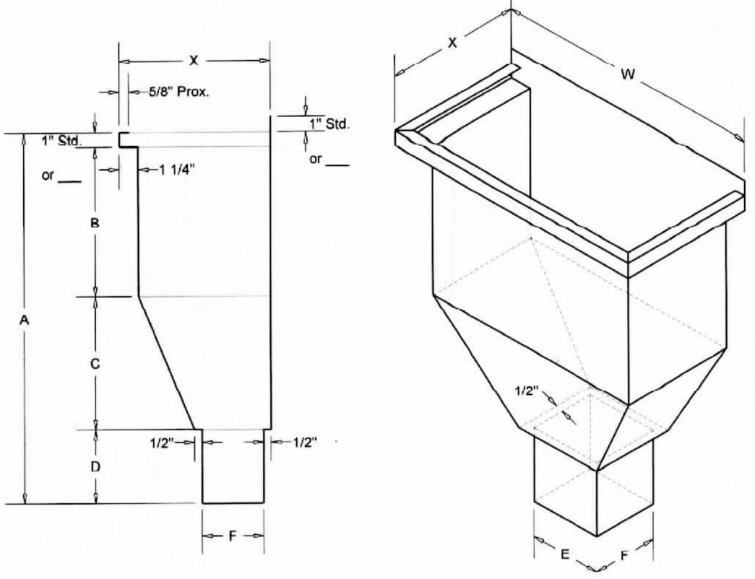**West Fellowship wall, high up, south (to the left of from inside) of the door into the Bell Tower.** Damage from water coming through the wall is readily apparent on the inside. The building across Jefferson Street from the church, but facing Rockville Road was torn down and a new building built a year or 2 ago. The original all brick building had an area on the rear wall about 8 feet in diameter completely collapse. The urgency of this project is based on concern that something similar could happen with our wall. We believe that the problem in the area in question is a design problem, and that the problem has been occurring since the church was built. This area needs to be repointed and then sealed with a flat finish brick and mortar sealer. The gutter needs to be replaced with what is called collector. A collector is essentially an oversize

bottomless gutter where what would have been the bottom of the gutter merges into a connection to a downspout. See illustration.

**West Wall, southwest corner of the Fellowship Hall. Water coming in through the walls.** This had been thought to be from water coming under the emergency

door when the drain stopped up. From new damage up higher on the wall it is now apparent that the problem is water coming through the wall. This is a foundation wall issue. Priority is both aesthetic and structural.

**South Sanctuary Downspout Drains.** The Fellowship Hall water issue led to an investigation into the underground drains for the South Sanctuary roof. These drains appear to empty into the alley. It was found that water running into these drains does not come out into the alley. The only other place for it to be going is into the mixed-use sewers, which is common, but illegal. We have not verified that they are draining into the sewers. It also appears that two downspouts for this roof are marginal in capacity, and given the amount of roof drained and the steepness of the roof, there should probably be a third downspout.

**Clinton Street east wall water damaging plaster**. This problem has been fixed, but not completely repaired. investigation indicated that paint was pulling away from the outside mortar joints on this wall, exposing possible places for water entry. These joints were caulked and the plaster repaired, with no signs of additional damage. This area needs to be watched, and if further damage occurs the wall will need to be tuck pointed.

**Downstairs Furnaces date from the end of the last century.**

Both of these HVAC systems we installed in the last 1990s making these furnaces around 25 years old. The AC unit in the Fellowship Hall was replaced in September of 2022. The board decided not to switch to a heat pump at the time because of the expense and the age of the furnace. The RE area unit could go at any time, but most likely in the summer or winter. The Fellowship Hall unit probably will be OK at least until fall, given that winter is mostly over.

**Other masonry issues.** There are failing brick on the Clinton Street entrance west wall at the top outside of the building (wing wall). As mentioned in the west sanctuary wall report, the brick below the gutter that will be replaced by a collector needs to be pointed and sealed before the gutter work is done. There are also spalling brick (face of the brick coming off) in the alley to the east. We can wait to see if additional spalling takes place since this wall is in the alley

Attic Vents – do not plan to proceed with this work at this time. This is important as it increases the life of the roof, but not urgent.

# Cost Estimates for this work

**Masonry Repairs –** (other masonry issues) **notes**

Pavan Masonry $6500 Includes more work than Triple M for 75 percent of the cost

Triple M Masonry $8750

### Foundation Work

Robert Haines Company $5650

Smock Fansler $26,361

### Gutter work and added downspout

Cornett Roofing $4200

2nd contractor

3rd vendor contractor

**Downspout drains**

|  |  |  |
| --- | --- | --- |
| 1st vendor (TBD)  2nd vendor * (TBD) 3rd vendor * (TBD) |  | |
| **Furnaces** |
| Fellowship Hall – furnace only | $4175 | Quotes from Rinehart |
| RE – 85% furnace and heat pump | $9228 |  |
| *vendors have been contacted |  |  |